**Ideation Phase**

**Define the Problem Statements**

|  |  |
| --- | --- |
| Date | 16 June 2025 |
| Team ID | LTVIP2025TMID40189 |
| Project Name | GrainPalette - A Deep Learning Odyssey In Rice Type Classification Through Transfer Learning |
| Maximum Marks | 2 Marks |

**Customer Problem Statement Template:**

Farmers, agricultural researchers, and home growers often face difficulties in accurately identifying rice grain types due to the lack of accessible tools and expert knowledge. This uncertainty affects critical decisions such as irrigation planning, fertilizer use, and pest control, leading to reduced crop efficiency and lower yields. Traditional identification methods are time-consuming, require expert intervention, or are not scalable for widespread use, especially in rural or low-resource settings.

Users need a fast, accurate, and easy-to-use solution that allows them to identify rice varieties without relying on external experts or manual methods. They want to make informed decisions about crop management based on reliable information and desire a tool that works in local languages, supports offline use, and fits seamlessly into their existing farming or research workflow.

GrainPalette aims to solve this problem by providing an AI-powered image classification system that offers instant predictions of rice types through a simple photo upload — helping users make smarter, faster, and more confident agricultural decisions.

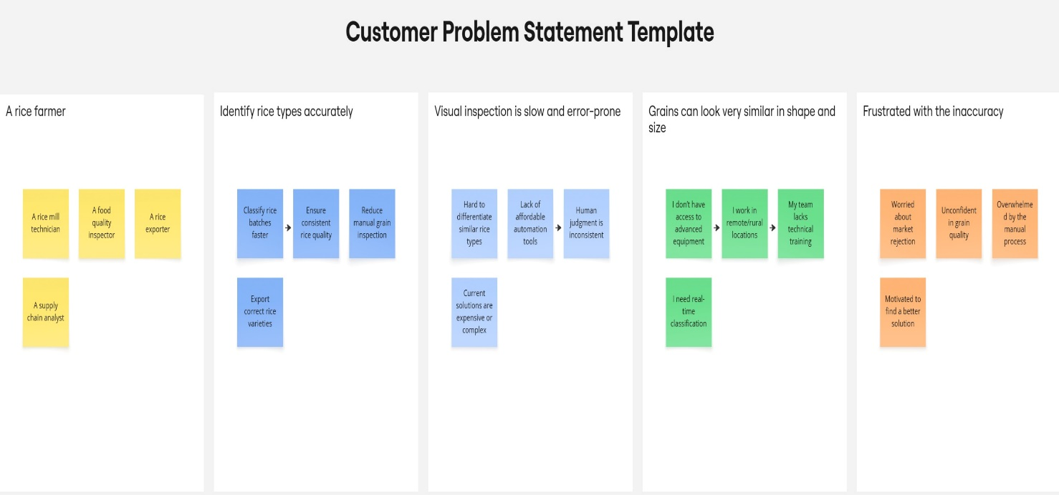

Reference: <https://miro.com/templates/customer-problem-statement/>

|  |  |  |  |  |  |
| --- | --- | --- | --- | --- | --- |
| **Problem Statement (PS)** | **I am (Customer)** | **I’m trying to** | **But** | **Because** | **Which makes me feel** |
| PS-1 | A rice farmer | Identify rice types in my harvest accurately | I rely on manual inspection | Its hard to tell types apart visually | Unsure, frustrated, and worried about selling low-quality rice |
| PS-2 | A rice mill technician | Quickly classify rice batches during processing | I don’t have time for detailed checking | Manual methods are slow and error-prone | Pressured,inefficient,and stressed |